ENGAGE DB
BACSE202 – Database Management Systems | Digital Assignment | Fall 2026–2027
VIT Chennai | Faculty: Dr. S. Geetha | D1 + TD1 | CH202670101707

TEAM MEMBERS
Narasimhan D 25BCE5028
Shri Vishwa 25BCE5127
Skanthan C 25BCE5175

ABSTRACT
ENGAGE DB is an educational social networking application built using Flask and PostgreSQL, with an optional Oracle database mirror. Users can create posts, like and save posts, add comments, and follow one another. The database stores these activities in separate, well-organized tables so that the relationships between users, posts, and interactions remain clear. The project also considers students’ learning goals, monthly budgets, and preferred learning methods. These details, along with the topics users interact with, are used to rank fictional learning resources and show why a resource may be a suitable match. Through the application, we demonstrate important DBMS concepts such as table creation, primary and foreign keys, joins, grouping, subqueries, views, transactions, data synchronization, and testing. The original ER design contains 12 core tables. The Oracle sample extends this to 15 tables, while the PostgreSQL version also includes supporting tables and analytical views. We have clearly separated features observed in the source code and sample data from tests that still need to be run locally.

Keywords—Relational DBMS, PostgreSQL, Oracle, Flask, normalization, social engagement, explainable recommendation, SQL.

1. Introduction and problem statement
Social media platforms make it easy for users to share content, like posts, and comment on them. However, these interactions do not usually take a student’s learning goals or budget into account. For example, a student preparing for an examination may need resources that match both the exam they are targeting and the amount they can afford to spend. ENGAGE DB brings these ideas together in a familiar social-media-style application. It records user interactions in a relational database and uses the student’s stated preferences to explain why certain learning resources are recommended. The main aim of this project is to build a working application that demonstrates DBMS concepts in a practical way, rather than presenting only separate SQL queries.

2. Objectives, intended users and scope
• Design and normalize 12 connected engagement entities using primary keys, foreign keys, unique constraints, and composite keys.
• Build at least five application features that interact with the database: creating a post, liking, saving, commenting, and following.
• Use indexes and SQL operations such as JOIN, GROUP BY, nested queries, and views to retrieve and analyse engagement data.
• Store each student’s learning preferences and use clear score components to rank fictional educational resources.
• Synchronize selected baseline data from PostgreSQL to Oracle for a separate SQL*Plus demonstration.
• Check valid and invalid inputs, duplicate entries, key constraints, and common database read and write operations.
The project is a small educational proof of concept that uses sample data. It is not a commercially verified recommendation system, a source of live market prices, or a fully authenticated social network designed for large-scale use.

3. Existing systems and base literature
Social media platforms such as Instagram (https://www.instagram.com/) show how users can share posts, like content, and leave comments. Learning platforms such as Khan Academy (https://www.khanacademy.org/) help users discover educational material and structured learning resources. ENGAGE DB takes ideas from both types of platforms: it records social interactions while also considering the learning preferences entered by students. These examples are used to explain the type of systems that inspired the project; they are not part of a formal usability comparison.
The survey by Batrinca and Treleaven [1] discusses different methods, tools, and platforms used to analyse social-media activity. This provides useful background for the way ENGAGE DB collects and studies user interactions. Our project has a narrower focus: it uses relational database constraints, repeatable SQL queries, and rule-based scores that explain how a student is matched with a learning resource. The original project ZIP did not include screenshots of the external websites. The team still needs to capture suitable screenshots and cite them before the final submission.

4. Requirements and proposed architecture
Layer | Technology | Responsibility
Presentation | HTML, CSS, JavaScript | Social feed, profile, interactions, learning view
Application | Python / Flask 3.0.3 | HTTP routes, input checks, SQL access and responses
Primary DB | PostgreSQL + psycopg | Persist all live engagement/application data
Optional DB | Oracle Free / python-oracledb | Explicitly synchronized snapshot for Oracle demonstration
Fig. 1. Application connectivity observed in the project. Oracle data is updated through a separate synchronization step, not through live dual-writing.

5. ER model and relational schema

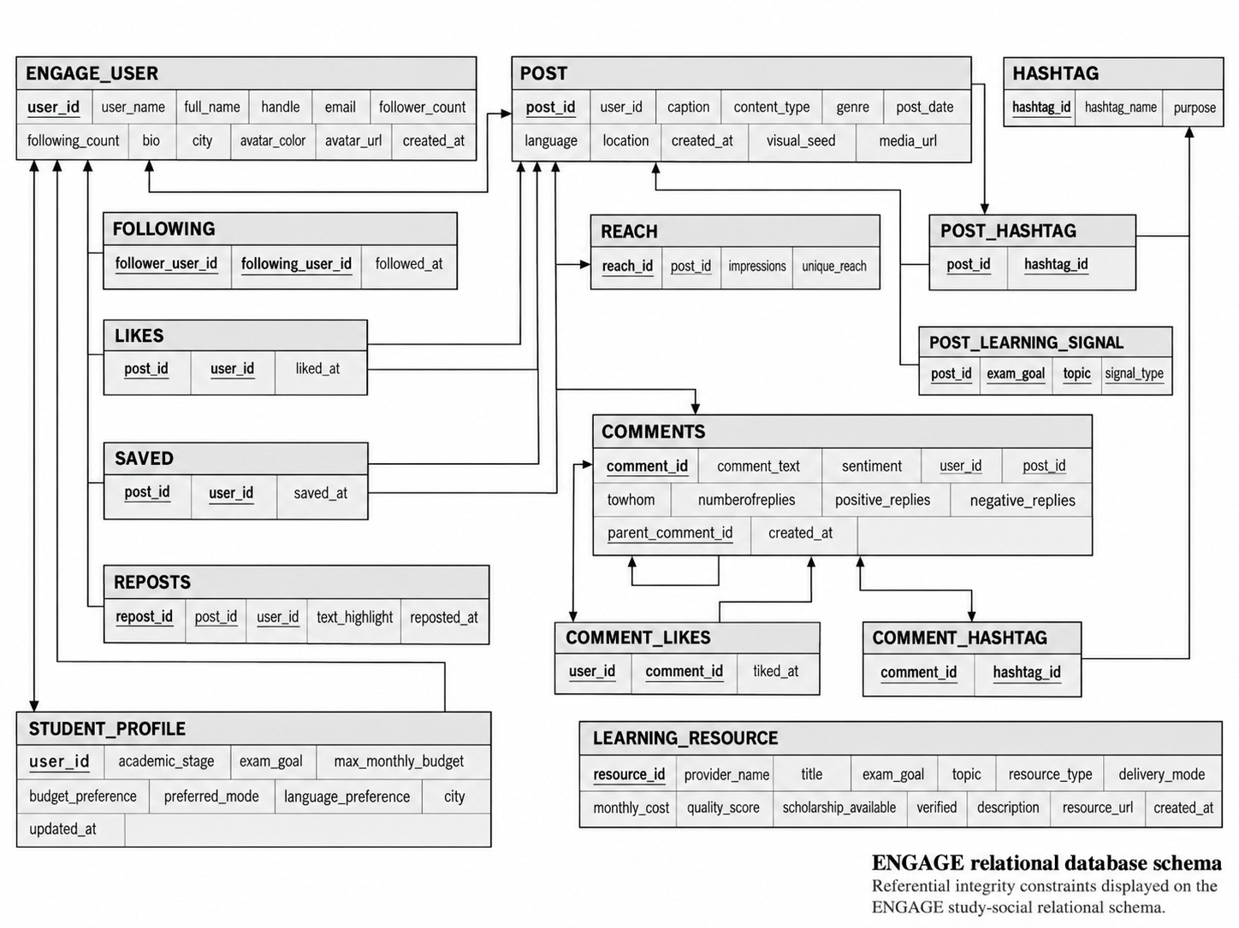

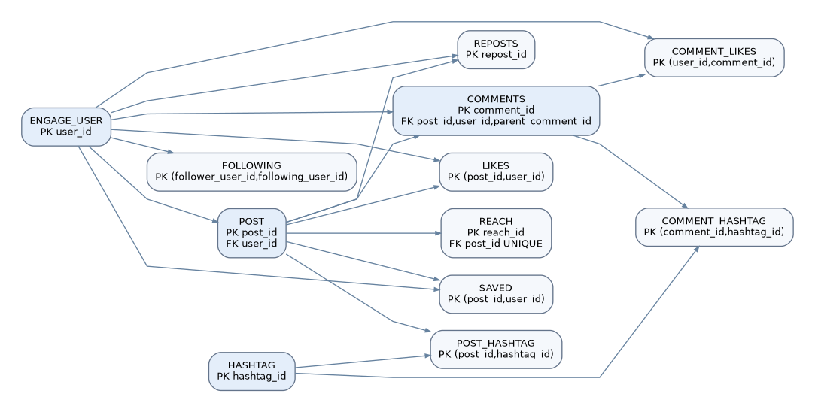
Fig. 2. Main relationships and key structure of the 12 core entities, based on the database definition.
Core table | Primary key | Foreign keys | Use
ENGAGE_USER | user_id | - | Identity and profile
POST | post_id | user_id | Post attributes
FOLLOWING | follower_user_id + following_user_id | both -> ENGAGE_USER | Directed user relationships
LIKES | post_id + user_id | POST, ENGAGE_USER | Post likes
SAVED | post_id + user_id | POST, ENGAGE_USER | Saved posts
REPOSTS | repost_id | post_id, user_id | Reshared posts
HASHTAG | hashtag_id | - | Hashtag dictionary
POST_HASHTAG | post_id + hashtag_id | POST, HASHTAG | Post to tag junction
COMMENTS | comment_id | post_id, user_id, parent_comment_id | Comments and replies
COMMENT_LIKES | user_id + comment_id | ENGAGE_USER, COMMENTS | Likes on comments
COMMENT_HASHTAG | comment_id + hashtag_id | COMMENTS, HASHTAG | Comment to tag junction
REACH | reach_id | unique post_id | Impressions and unique reach
The Oracle sample contains 15 tables. In addition to the 12 core tables, it includes STUDENT_PROFILE (with user_id as its primary and foreign key), POST_LEARNING_SIGNAL (with post_id as its primary and foreign key), and LEARNING_RESOURCE (with resource_id as its primary key). The PostgreSQL database also contains supporting operational tables, indexes, and analytical views. An application view should not be counted as a physical Oracle table.

6. Functional dependencies and normalization
To understand the normalization process, consider an unnormalized record such as ENGAGE_RECORD(user_id, user_name, post_id, caption, {liked_by}, {hashtags}, {comments}). The lists of likes, hashtags, and comments repeat within the same record, which can lead to update and insertion problems. In First Normal Form (1NF), each value is stored atomically and each interaction is represented separately. In Second Normal Form (2NF), user details are moved to ENGAGE_USER and post details to POST, so they do not depend on only part of a combined key. In Third Normal Form (3NF), details such as hashtag_name and comment_text are stored in their own tables. This reduces transitive dependencies and keeps the engagement records easier to maintain.
Functional dependency | Implication
user_id → user_name, handle, email, city | User attributes live in ENGAGE_USER
post_id → user_id, caption, genre, post_date | Post content lives in POST
hashtag_id → hashtag_name, purpose | Tag text lives in HASHTAG
comment_id → user_id, post_id, comment_text | Comment detail lives in COMMENTS
(post_id,user_id) → liked_at | Post/user pair uniquely identifies a like
(post_id,user_id) → saved_at | Post/user pair uniquely identifies a save
Some values are stored in a slightly different way to make common operations easier. For example, follower_count and following_count in ENGAGE_USER store cached totals calculated from FOLLOWING, while REACH stores post-performance counters. The follow feature updates the cached counts whenever a user follows or unfollows someone. These values should be checked against the actual relationship records to make sure they remain correct. The key constraints in the main junction tables support the BCNF discussion, but we do not claim that every additional table has been fully proven to be in BCNF. The detailed decomposition is available in docs/NORMALIZATION.md.

7. Database implementation and sample data
The ENGAGE_DB source package includes postgres_schema.sql, setup_postgres.py, seed.py, sample_data.py, and optional scripts for setting up and synchronizing Oracle. For the faculty demonstration, the repository keeps the Oracle files separate: the table definitions are in database/schema.sql, the sample records are in database/sample_data.sql, and the 13 assigned analytical queries are in database/queries.sql. All records are synthetic and were not collected from real students or education providers. The baseline sample contains 237 records in the 12 core tables and another 35 records in the three learning-related tables.
Table | Baseline rows | Table | Baseline rows
engage_user | 10 | post | 16
following | 31 | likes | 43
saved | 16 | reposts | 8
hashtag | 20 | post_hashtag | 48
comments | 12 | comment_likes | 8
comment_hashtag | 9 | reach | 16
student_profile | 10 | post_learning_signal | 16
learning_resource | 9 | TOTAL | 272
The figures above represent the number of INSERT statements prepared in the sample-data script. They are not the result of running independent count queries on the current database. The application may also create more records when its data-expansion routines are used.

8. Five application-to-database features
Function | Frontend to Flask | Writes / verification
Publish Post | POST /api/post | POST, REACH; optional HASHTAG and POST_HASHTAG
Like/Unlike | POST /api/post/<post_id>/like | Insert/delete LIKES; check count
Save/Unsave | POST /api/post/<post_id>/save | Insert/delete SAVED; check saved status
Comment | POST /api/post/<post_id>/comment | COMMENTS and optional COMMENT_HASHTAG
Follow/Unfollow | POST /api/follow/<target_id> | FOLLOWING and cached follower counters
The application checks that post captions and comments are not left blank and returns HTTP 400 when they are. It also prevents a user from following their own account. However, some primary-key or foreign-key errors may still appear as database error messages instead of clear messages for the user. This is a known limitation that should be tested and documented.

9. Student opportunity intelligence and formula logic
The application combines a student’s activity by topic to estimate their interests. In the PostgreSQL student_topic_scores view, likes have a weight of 1, saves 4, comments 3, and reposts 5. Post-view time also contributes through a capped dwell-time factor: min(1.5, 0.20 + min(dwell_seconds,20)/20). A view therefore adds a smaller amount of weight than a direct interaction. The system does not try to estimate a student’s income. Instead, it uses the learning preferences and budget that the student has entered.
The total resource score is calculated as: goal_score + interest_score + affordability_score + mode_score + quality_score / 2. In the SQL view, an exact exam-goal match receives 35 points, while a non-match receives 5. The interest score is capped at 30 and is calculated as min(topic_score × 2, 30). A free resource or one within the student’s budget receives 25 affordability points; defined alternatives close to the budget receive 18 or 12 points, and other resources receive 0. The preferred learning mode, or a hybrid option, adds 5 points. The budget and learning mode are taken directly from the student’s profile.
The project also has a separate course-trending view. It calculates course demand using likes ×1, shares ×2, comments ×4, saves ×3, and reposts ×5. This score is meant to show overall course interest; it is different from the score used to recommend resources. The two supplied screenshots show the affordability score increasing by 25 points when the student changes the budget from ₹20 to ₹20,00,000. These screenshots show the change in the application interface, but separate database test evidence still needs to be collected.
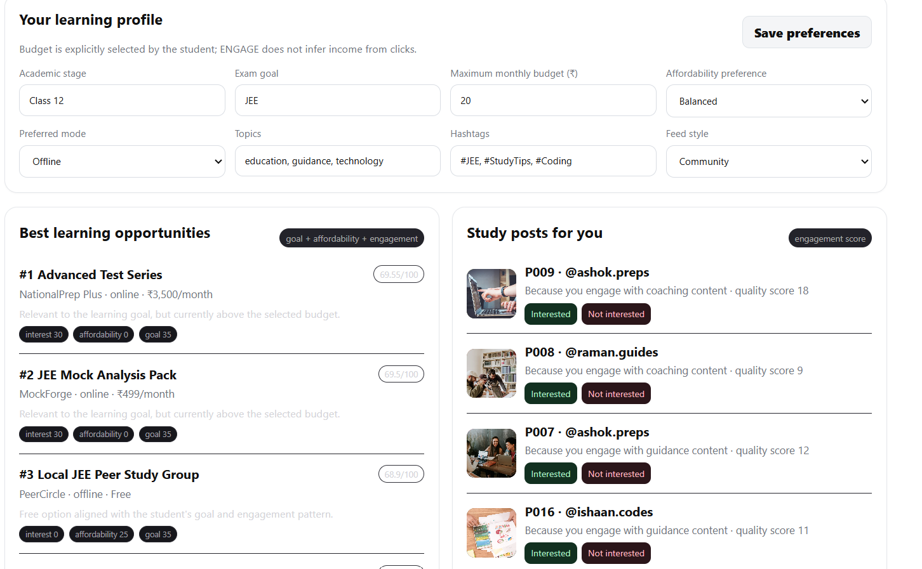
Fig. 3. Application screenshot with a student budget of ₹20 per month; the resource is outside the budget.
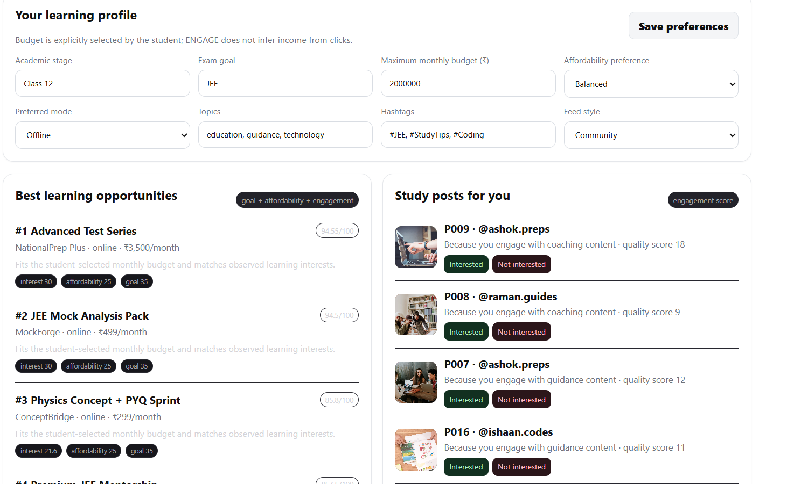
Fig. 4. Application screenshot after changing the student budget to ₹20,00,000 per month; the affordability score increases.

10. SQL operations and faculty queries
The SQL queries in this project cover basic data selection and filtering, joins, aggregate functions, nested queries, sorting, and LEFT JOINs. A LEFT JOIN is useful here because it can also show posts or hashtags that have no related interactions. All 13 assigned queries are available in database/queries.sql. A few examples are shown below:
SELECT p.post_id, COUNT(c.comment_id) AS total_comments
FROM post p LEFT JOIN comments c ON c.post_id=p.post_id
GROUP BY p.post_id ORDER BY total_comments DESC;

SELECT h.hashtag_name, COUNT(ph.post_id) AS usage_count
FROM hashtag h LEFT JOIN post_hashtag ph ON h.hashtag_id=ph.hashtag_id
GROUP BY h.hashtag_name ORDER BY usage_count DESC;

SELECT post_id, COUNT(user_id) AS total_saves FROM saved
WHERE post_id=(SELECT MIN(post_id) FROM saved) GROUP BY post_id;
The Oracle transaction example demonstrates a set of CRUD operations in one transaction. It uses SAVEPOINT, INSERT, SELECT, UPDATE, DELETE, and ROLLBACK TO SAVEPOINT with a disposable demo user ID. The script is available in database/crud_transaction_demo.sql. It should only be run in a suitable test schema.

11. Testing methodology and evidence status
The repository contains tests/TEST_RESULTS_TEMPLATE.md, which lists 14 test cases and their expected outcomes. By reviewing the submitted source files, we could confirm the Flask routes, table definitions, input checks in the code, and the sample records. The two supplied screenshots also show that the resource score changes when the student’s budget is changed. However, a PostgreSQL or Oracle service was not available for a complete end-to-end test in this environment. For that reason, we have not marked all the test cases as passed.
Type | Expected evidence | Current status
Python source compilation | All distributed Python files parse | Automated local static verification prepared
Post / like / save / comment / follow | UI before/after and matching DB rows | Pending team execution
Invalid input / self-follow | HTTP 400 and unchanged DB rows | Validation visible in source; runtime pending
Constraints / duplicate | PK/FK rejection | Pending team execution
Recommendation budget | Different score/affordability | Two actual team screenshots available
Oracle mirror | Actual Oracle count/query screenshot | Pending new capture
Existing-system comparison | Permitted website screenshots + URLs | Pending team capture
The team should update each test status only after running the test, checking the actual output, and saving the required evidence. The date, expected result, and actual result should also be recorded. The sample-data counts may change if more records are added. In SQL*Plus, DBMS_LOB.SUBSTR may be needed when grouping by a caption stored as a CLOB.

12. Limitations, future work, and ethics
At present, ENGAGE DB is a demonstration application rather than a production-ready social network with strong authentication. The provider names, prices, and profiles used for recommendations are fictional. The Oracle database is updated only when the synchronization script is run, and some views may still calculate scores for resources that are above a student’s budget. The interface should make this clear or filter those resources where needed. Performance at a large scale has not been measured. Possible improvements include better permission checks, automated database migrations, clearer input validation and error messages, checks for recommendation fairness, measured indexing and pagination, and automated integration tests.
Before sharing the project repository, the team should retain proper credit for the papers and libraries used. Local .env files, login credentials, virtual environments, private data, and uploaded files that have not been checked should be removed.

13. Conclusion
ENGAGE DB brings database design and a working social-style application together with a way to explore learning resources. Its 12 core tables represent users, posts, and the different types of engagement. The learning-related tables add student preferences and budget-based resource comparisons. The source code and sample data demonstrate the main DBMS features planned for the project. Before final submission, the team still needs to verify the application workflows on its own system, capture database query results, show that the project can be installed in a clean environment, and complete the three-member demonstration video.

References
[1] B. Batrinca and P. C. Treleaven, “Social media analytics: a survey of techniques, tools and platforms,” AI & Society, vol. 30, pp. 89–116, 2015, doi: 10.1007/s00146-014-0549-4.
[2] PostgreSQL Global Development Group, “PostgreSQL Documentation.” https://www.postgresql.org/docs/ (accessed Nov. 2026).
[3] Pallets, “Flask Documentation.” https://flask.palletsprojects.com/ (accessed Nov. 2026).
[4] Oracle, “Oracle Database Documentation.” https://docs.oracle.com/en/database/ (accessed Nov. 2026).
[5] ENGAGE DB project source, “DBMS-FINAL.zip,” team-provided archive, Nov. 2026.

Appendix A. Contribution and deliverable verification
The presentation work is divided equally as a proposed plan: D Narasimhan is assigned the frontend, post/comment features, and database integration; D Shri Vishwa is assigned the ER model, keys, constraints, normalization, likes, and saves; and Skandhan is assigned recommendations, analytics, follows, and test evidence. Each member is allocated 33.33% of the presentation and a similar-length video section. The team should confirm that this division reflects the work each person actually completed before submission.
The project repository is expected to include the application source code, database/schema.sql, database/sample_data.sql, database/queries.sql, test files, screenshots, the ER diagram, this report, an eight-slide presentation, and the Word submission sheet. The YouTube and GitHub links should be added after the project has been published.

